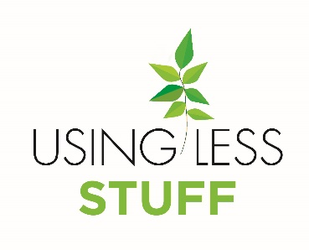

School Logo

Points to make when informing parents / carers of the Using Less Stuff Programme:
- Using Less saves money for the school that can then be spent more directly on education. It makes good economic business sense.
- Using Less engages pupils with diverse educational opportunities – from thermal imaging in physics to calculating energy use in maths and creating draft proofing in design technology. And many more.
- Using Less teaches the whole school community about education for social responsibility.
- Using Less projects teach pupils about their position in the wider community and the effect their choices can have around the world.
- Using Less is not about reducing comfort, it is about being more careful with the resources that we have – switching off lights when you leave a room, closing the windows when the heating is on etc.
- Parents may notice the effects of the Using Less behaviour change programme at home. It will be even more successful if parents get involved too. Let the school know how you are Using Less Stuff at home.

