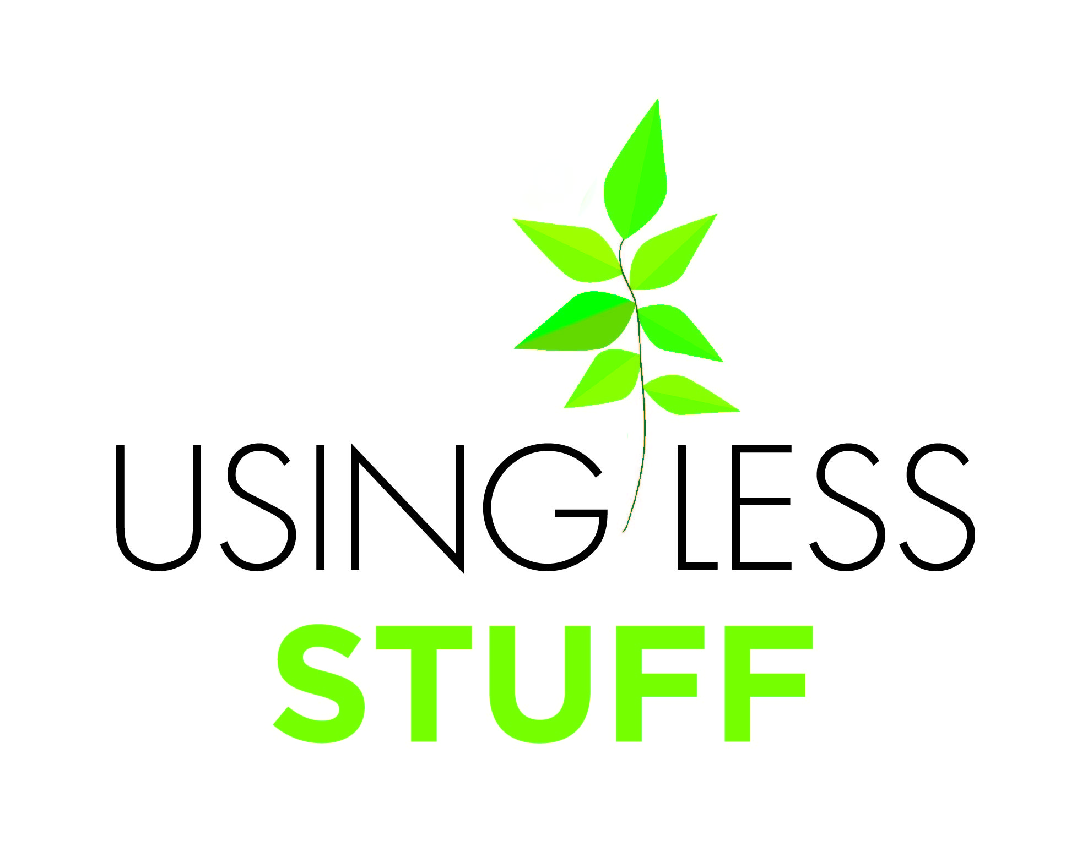
Class / Dept / House:
Information collected by: Date:

Name | “My Bit” to help the school Use Less Stuff

