The Alien at Dinner
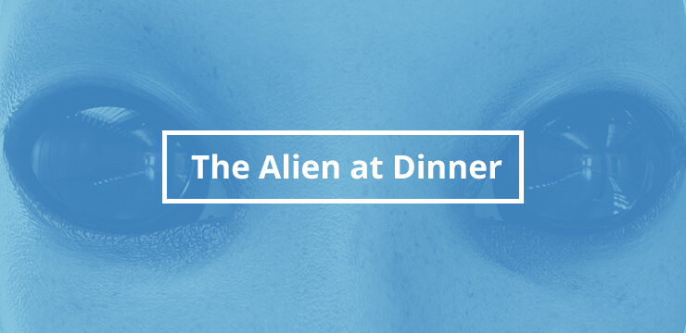

How to play:

Ask employees to imagine themselves as aliens observing a human dinner party. Their task is to point out unusual human social norms and to explain them to the beings on their imaginary planet. Why do they drink poisonous alcohol? Why do they knock their glasses together when celebrating?

What’s the point?
Encourage your employees to be more open-minded towards changing long-standing methods by The Alien at Dinner. This exercise helps to point out that just because something is accepted, does not mean it is the best or only way of doing something and that doing things the way they’ve always been done is not enough justification for resisting better methods.

